Your post processor is what converts the tool paths that you created in Fusion 360 into Gcode that the machine reads. With the addition of the Z axis some updates to the post processor need to be made.

If you have not already installed the post processor, watch the video below and it will explain how to install it.

<https://www.youtube.com/watch?v=63irIPuvPwg>

To edit the post processor click the post option as you would if you were looking to post a job then click the edit symbol.

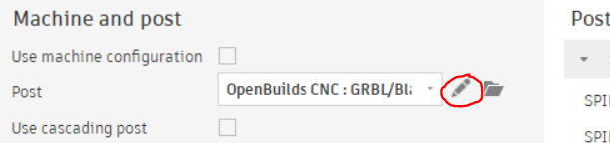

Once you open up the post processor you should see something like this.

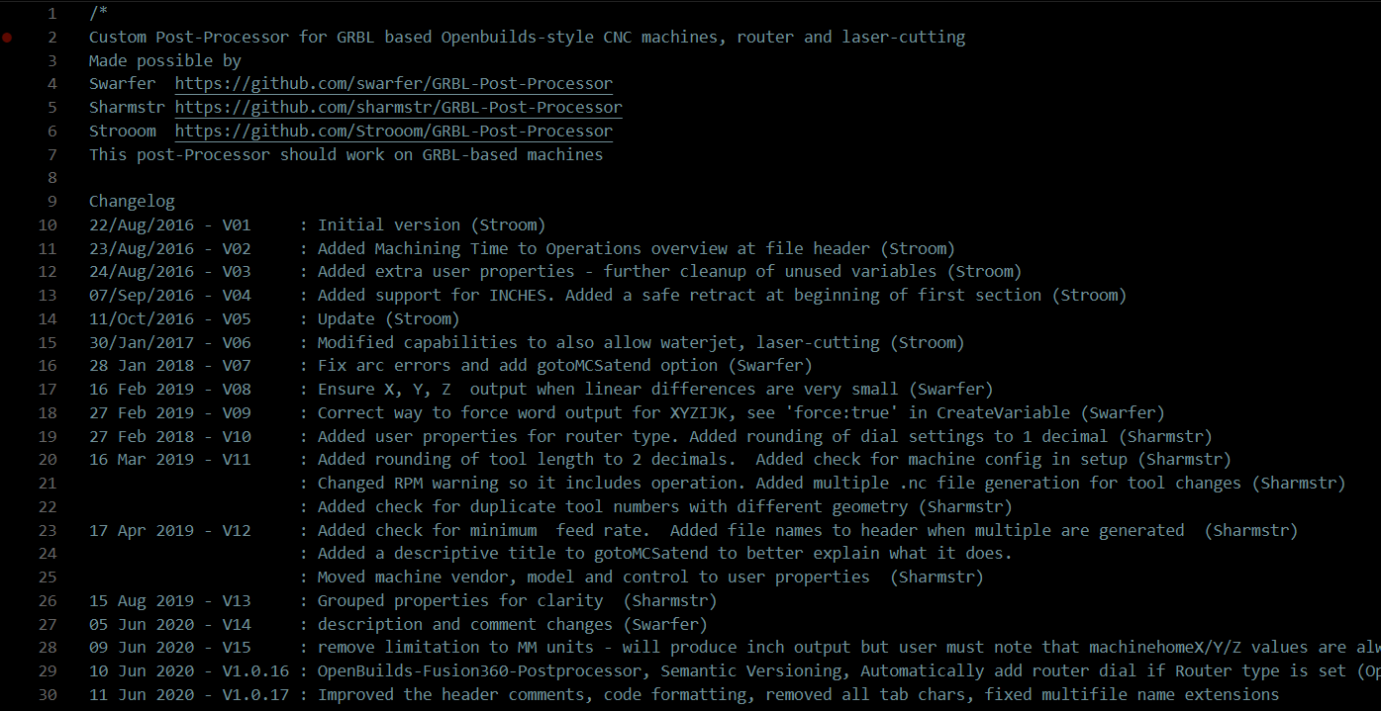

We need to make three changes. All of the changes are to the probing routine.

Scroll to line 232 and 233 and set plasma_probedistance = 100 and plasma_proberate = 150



Next scroll to line 775 and comment out lines 778 though 782. To comment out a line add // to the front of the line.

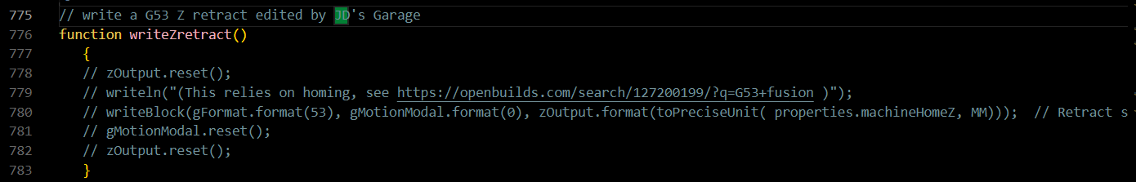

After these changes are made save the post processor and it is ready to be used. If you choose to remove the Z-Axis the changes will not affect the machine.